DIS-AM,C-Taino-2015 Dec 5

This expressive small head is made out of manatee bone. This is not a pendant but a votive object. Swirl eyes on the verso which suggests a drug induced trance while the reverse has a visage with slit eyes which suggests a trance state with an open mouth. Very well engraved front and back. Length 3.6 cm or 1.4 in. Originally from the Dominican Republic. Dating ca.1000-1500 A.D.

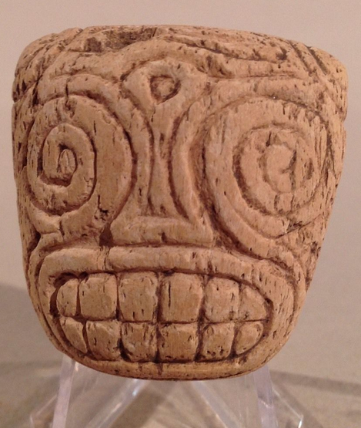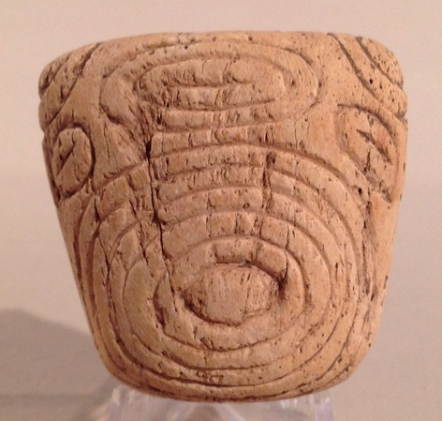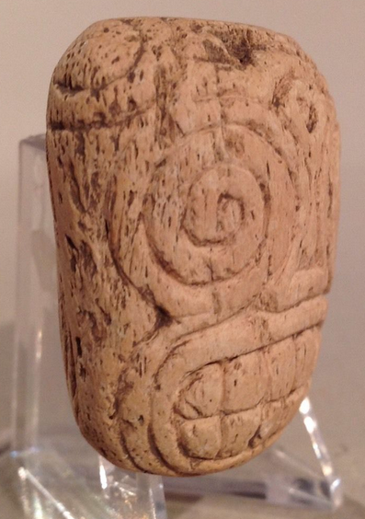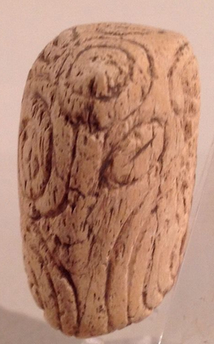

Taino pieces like this are normally described as bottles. Besides the 2 zoomorphic faces the shoulder on both sides have concentric circle like incising. This is the symbol for perpetual energy or the sun. There is no damage or repair of any kind. Height 14.7 cm. or 5.8 in. Originally from the Dominican Republic. Dating ca.1000-1500 A.D.

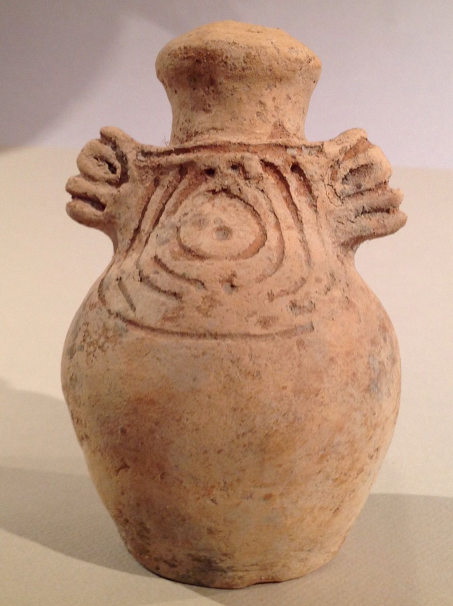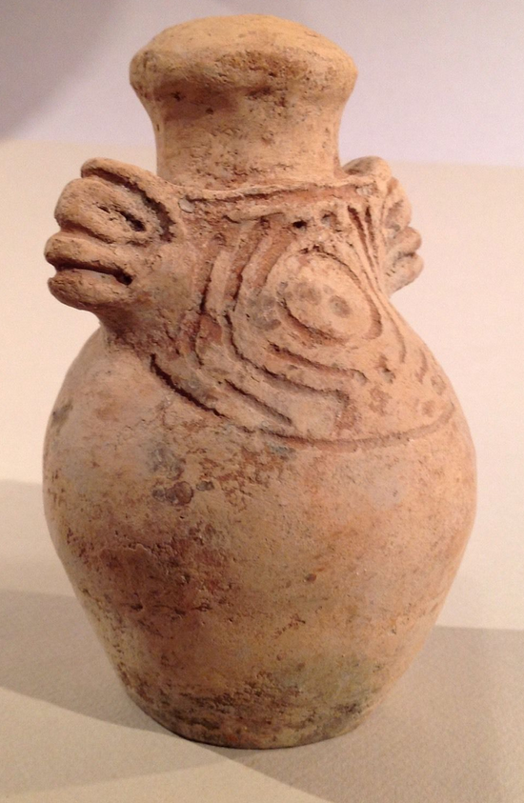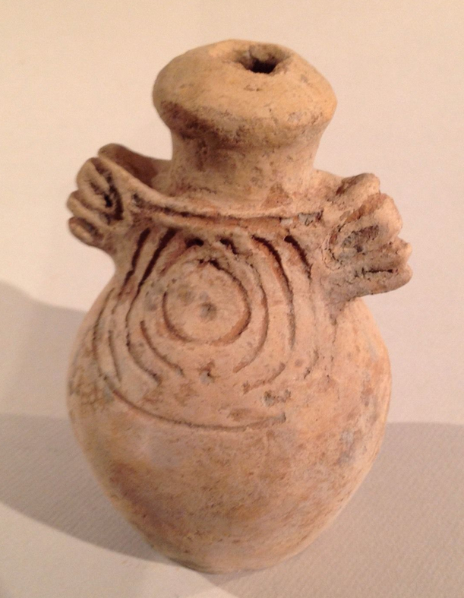

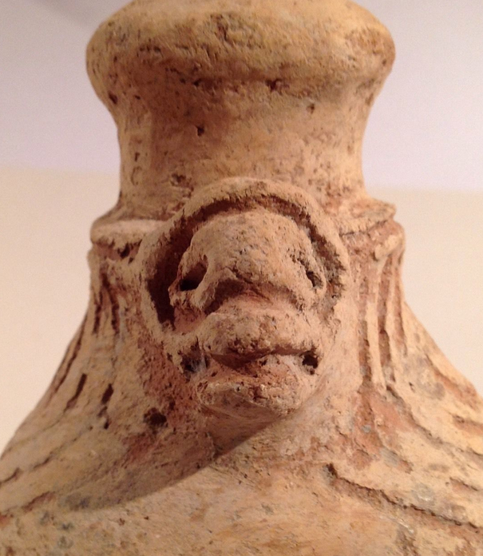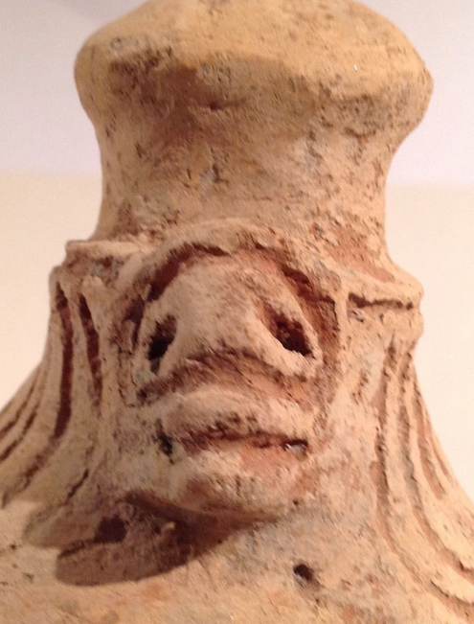

Looking closely at this piece I see that the suspension holes were not drilled through. Still it has a high polish, facial details, with torso and definable limbs. Figure appears to be straddling a post. The base is round so it could have been a small personal cohoba grinder. Caribbean Islands, probably the Dominican Republic or Puerto Rico. Length 8.8 cm. or 3.4 in. Dating ca. 1000-1500 A.D.

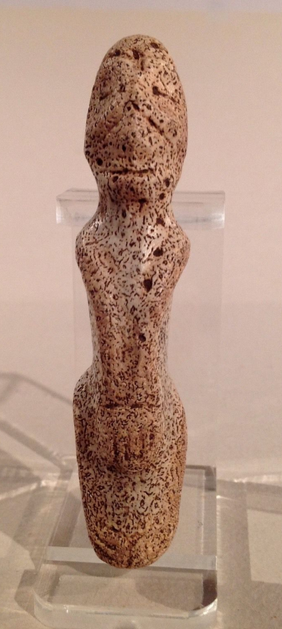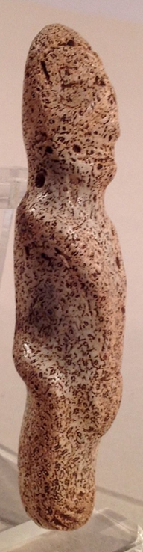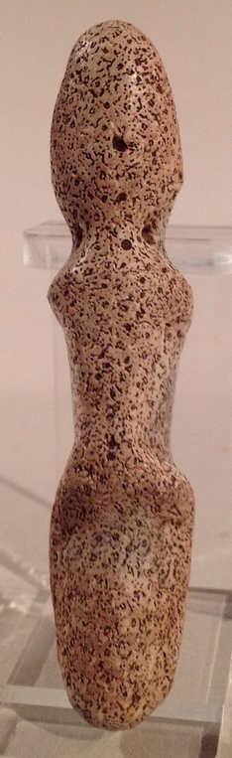

This figure has bulging eyes and slightly bulging lips. The limbs are curvilinear with hands resting on back of head. Made from fine-grained stone. Originally from the Dominican Republic, and dating ca. 1000-1500 A.D.

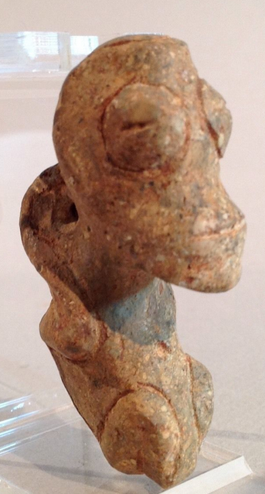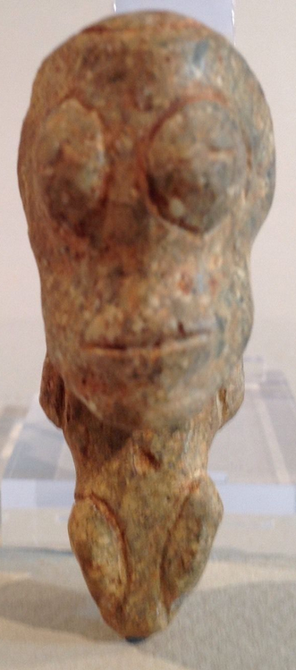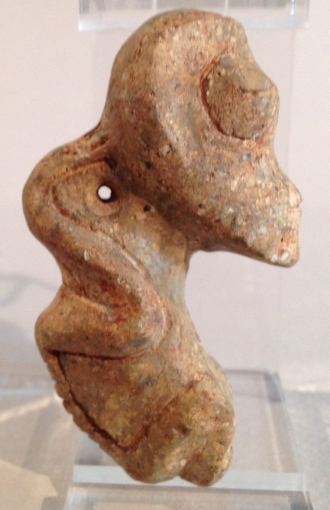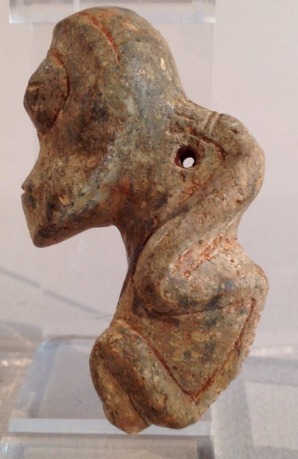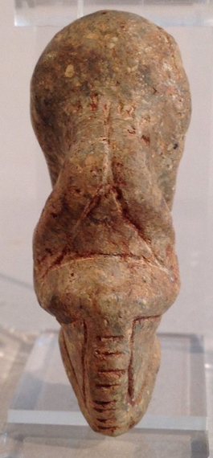

Because of its size this pendant was probably a point of focus piece used at specific ceremonies where bird allies were called upon for their knowledge of the cosmos. Made of a green spotted serpentine. It has large coffee bean eyes and is well engraved with symbolic icons. An unusual design. It measures 8.1 cm. or 3.2 in. Originally from the Dominican Republic and dating ca. 1000-1500 A.D. 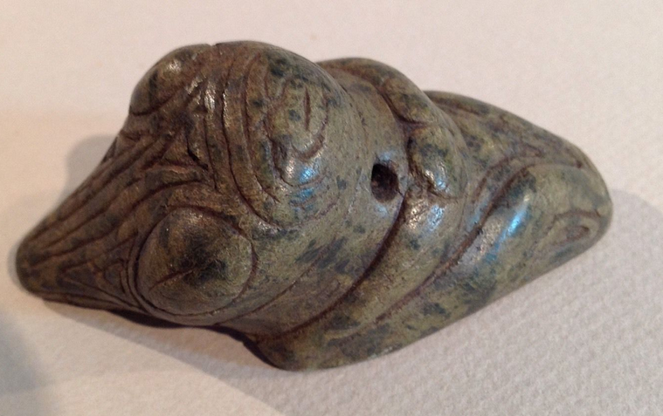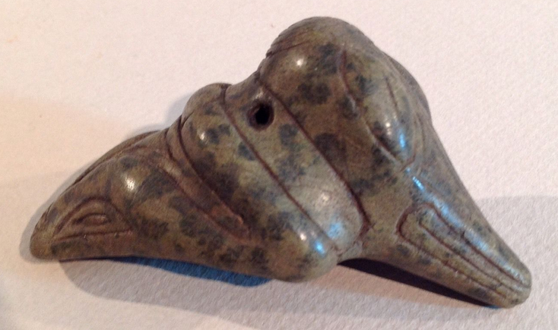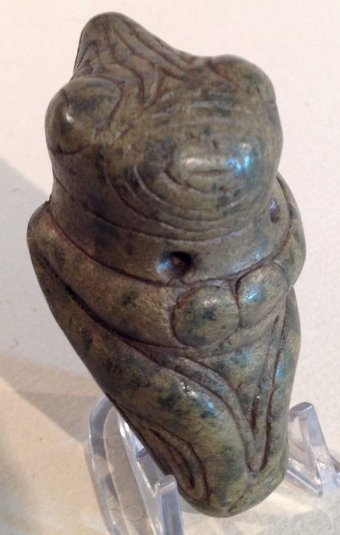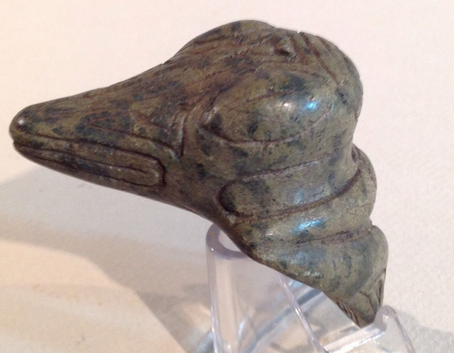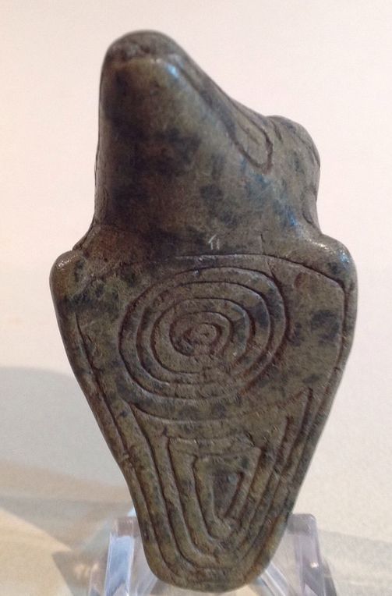

This pendant is made of fine-grained hard stone and has a striking band of silvery mica running through it. The reflective quality was hard to capture in the photos but when turned the right way the bottom half of the pendant turns a silver color. The figure appears to be a bird with long curvilinear legs suggesting a human connection. The round bulging eyes are accentuated by crescent shaped lines. Measures length 7.4 cm. or 2.9 in. Originally from the Dominican Republic. Dates ca. 1000-1500 A.D.

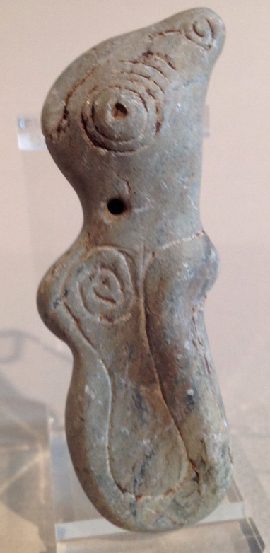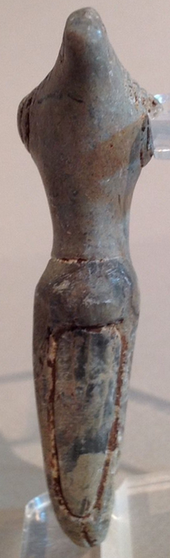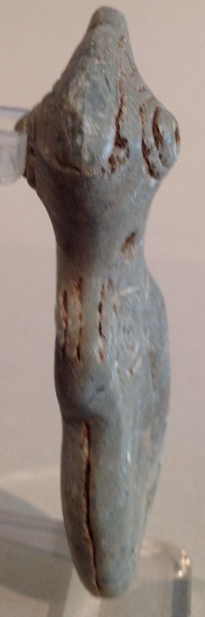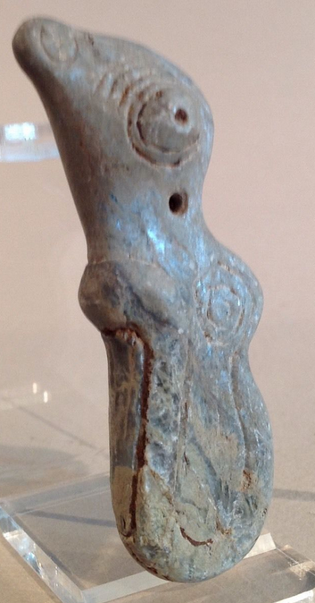

This pendant has a huge smile, and sunken eyes that are pierced at the nose ridge. There is a twin bird head symbol engraved at the top of the head. Arms are behind back with hands resting on subjects bottom. Round ball feet suggest the pendant may have been used as a personal small pestle for grinding cohoba in the small vessels commonly associated with Taino ceremonial accessories. Length 7.9 cm. or 3.1 in. Originally from the Dominican Republic and dating ca. 1000-1500 A.D.

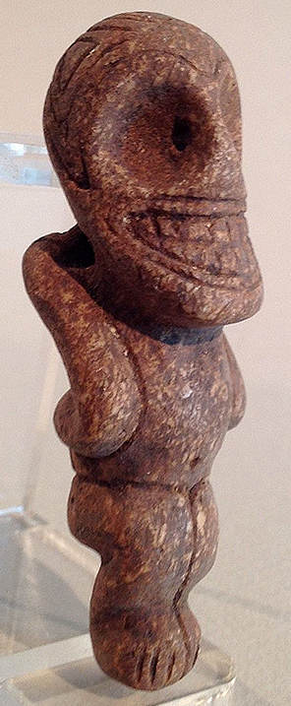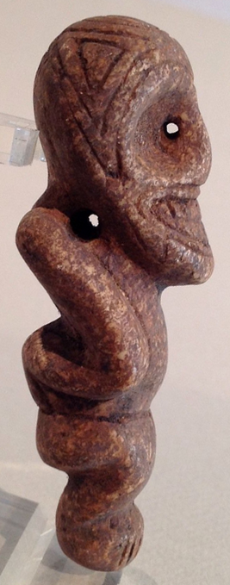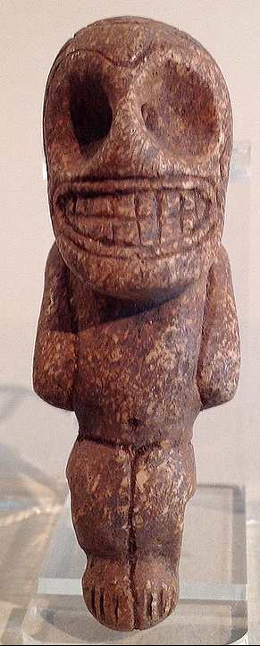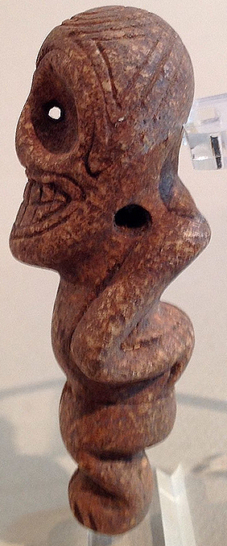

A very fine example of the Taino lapidary excellence. This pendant represents a shaman transformation from human to bird. Extended arms become a secondary bird-like head. Wings are interlocking bird head wind or hurricane symbols making this a feminine deity representation. Beautifully conceived in green serpentine with blackish spots. Measures 7.0cm or 2.7". Originally from the Dominican Republic and dating ca. 1000-1500 A.D.

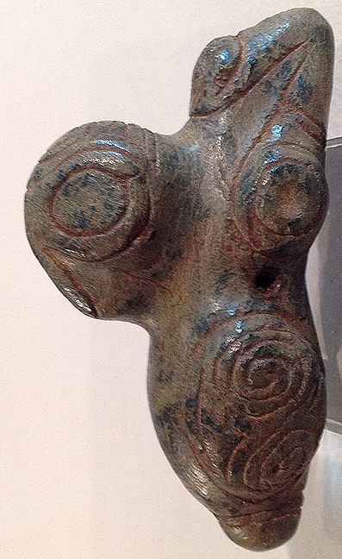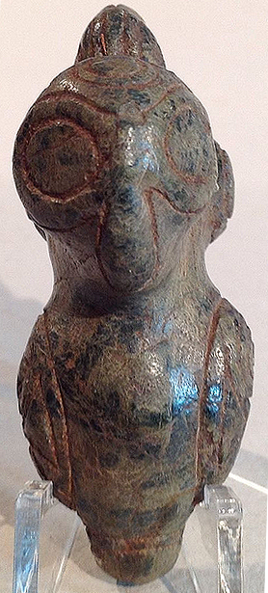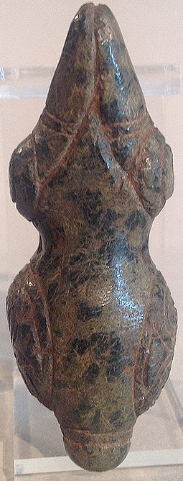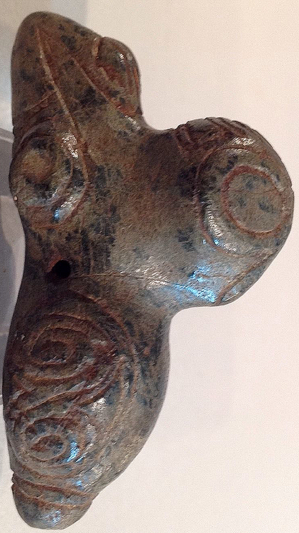

This piece is made of Manatee bone and features three figures in one. Looking at it top-down is a frogman-like figure. Turned on its side is a fish-like figure. Looking at the base is a skeletal anthropomorphic figure with a smiling face and prominent teeth. The nose is pierced and sides are engraved with water symbols. The nose holes are also the eyes for a bird head hidden in the design. The same symbolism can be seen on the base. A very interesting piece suggesting the experience ov being immersed in water in the trace state after taking cohoba, the experience of beinga frog and a fish and dying to one’s original being in this process. Similar experiences have been recorded by the San bushmen in South Africa in their pictographs. Measures, length 6.3 cm. or 2.5 in. Originally from the Dominican Republic and dating ca. 1000-1500 A.D.

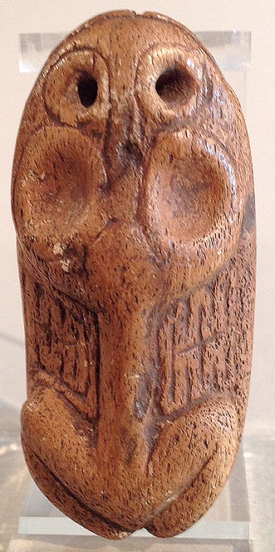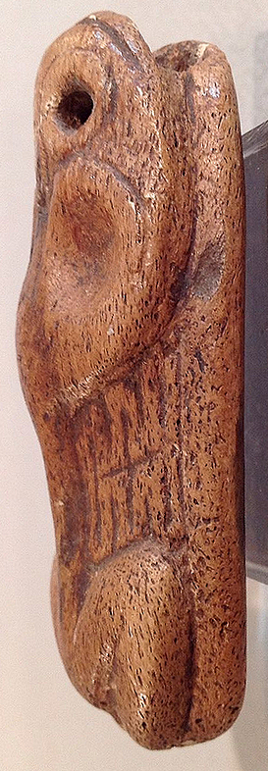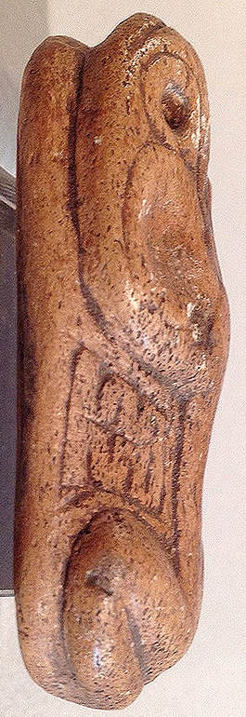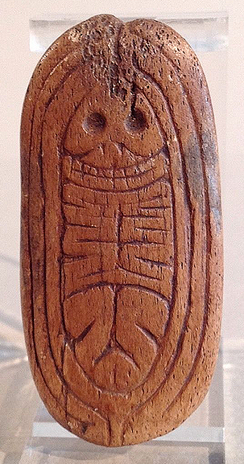

### Delivery package 1 of 1

No estimate available

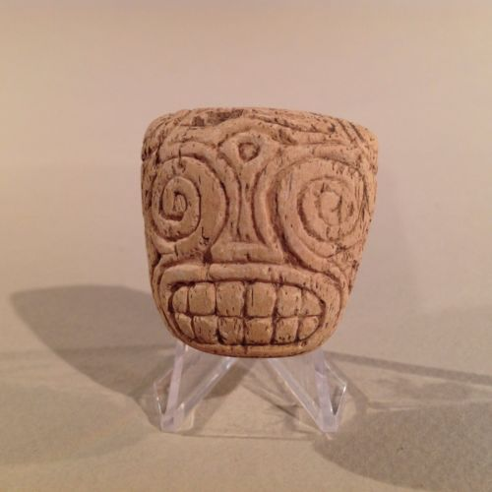

#### [Taino Head With Swirl Eyes PreColumbian](http://www.ebay.com/itm/262161060312)

|  |  |
| --- | --- |
| Item price | $117.50 |
| Quantity | 1 |
| Item number | 262161060312 |
| Shipping service | USPS Priority Mail |

## Sales order

Sold by [pulykapipi](http://myworld.ebay.com/pulykapipi) ( [216](http://feedback.ebay.com/ws/eBayISAPI.dll?ViewFeedback&userid=pulykapipi) )

### Delivery package 1 of 1

No estimate available

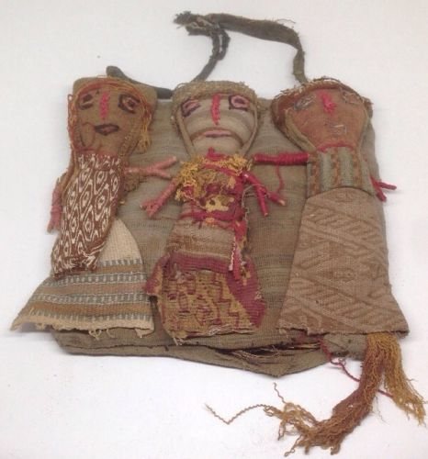

#### [Antique Peruvian Chancay Burial Grave Latin American Folk Art Doll Primitive C](http://www.ebay.com/itm/331720794805)

|  |  |
| --- | --- |
| Item price | $10.45 |
| Quantity | 1 |
| Item number | 331720794805 |
| Shipping service | USPS Priority Mail |

## Sales order

Sold by [flapast](http://myworld.ebay.com/flapast) ( [13264](http://feedback.ebay.com/ws/eBayISAPI.dll?ViewFeedback&userid=flapast) )

### Delivery package 1 of 1

No estimate available

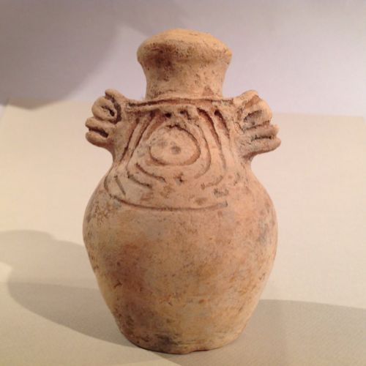

#### [Taino Pottery Bottle With 2 Faces Pre Columbian](http://www.ebay.com/itm/252186207618)

|  |  |
| --- | --- |
| Item price | $185.50 |
| Quantity | 1 |
| Item number | 252186207618 |
| Shipping service | USPS Priority Mail |

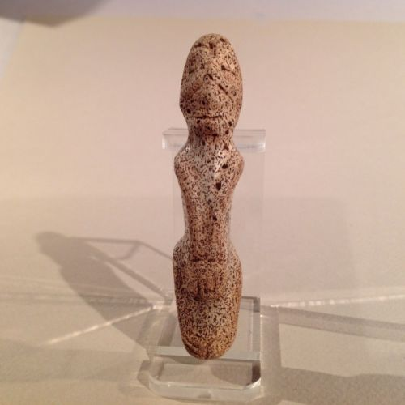

#### [Taino Anthropic Pendant, Fossil Coral Pre Columbian](http://www.ebay.com/itm/252186246241)

|  |  |
| --- | --- |
| Item price | $129.50 |
| Quantity | 1 |
| Item number | 252186246241 |
| Shipping service | USPS First Class Package |

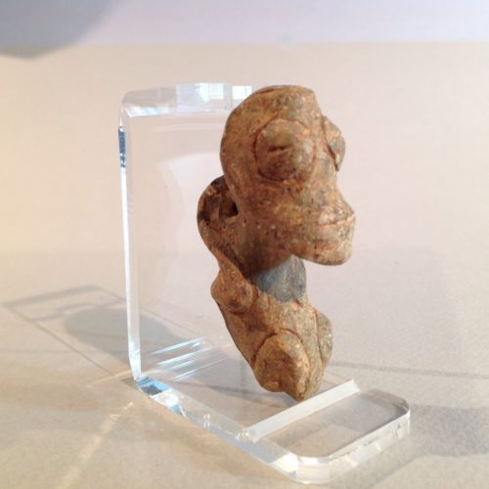

#### [Taino Stone Anthropic Pendant, PreColumbian](http://www.ebay.com/itm/252186280088)

|  |  |
| --- | --- |
| Item price | $177.50 |
| Quantity | 1 |
| Item number | 252186280088 |
| Shipping service | USPS Priority Mail |

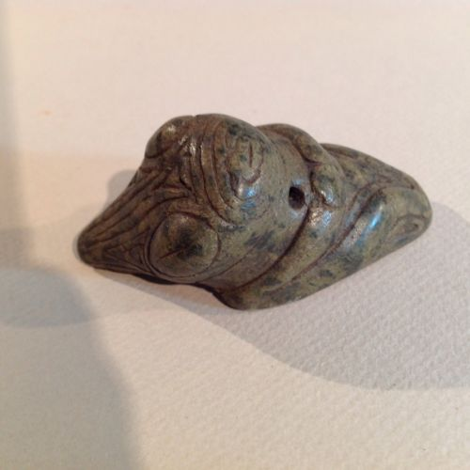

#### [Taino Large Serpentine Bird Pendant, PreColumbian](http://www.ebay.com/itm/252186301800)

|  |  |
| --- | --- |
| Item price | $132.50 |
| Quantity | 1 |
| Item number | 252186301800 |
| Shipping service | USPS Priority Mail |

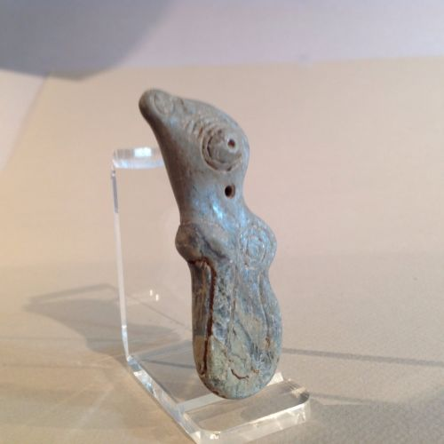

#### [Taino Stone Bird-Human Pendant Transformation, PreColumbian](http://www.ebay.com/itm/252186742894)

|  |  |
| --- | --- |
| Item price | $107.50 |
| Quantity | 1 |
| Item number | 252186742894 |
| Shipping service | USPS Priority Mail |

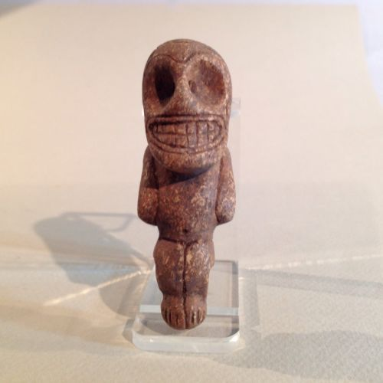

#### [Taino Stone Anthropic Pendant PreColumbian](http://www.ebay.com/itm/252186764000)

|  |  |
| --- | --- |
| Item price | $118.50 |
| Quantity | 1 |
| Item number | 252186764000 |
| Shipping service | USPS Priority Mail |

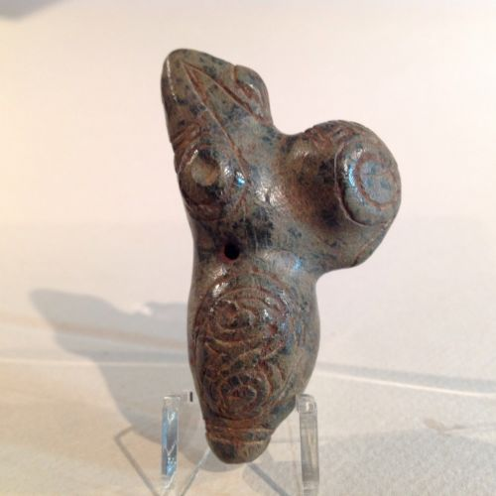

#### [Taino Pendant Serpentine Bird-Human Transformation PreColumbian](http://www.ebay.com/itm/252186809601)

|  |  |
| --- | --- |
| Item price | $132.50 |
| Quantity | 1 |
| Item number | 252186809601 |
| Shipping service | USPS Priority Mail |

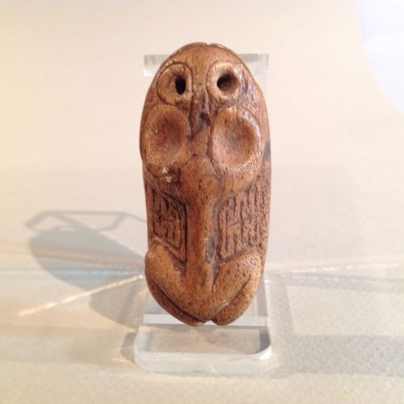

#### [Taino Frog-man Cemi With Secondary Figure PreColumbian](http://www.ebay.com/itm/262161608175)

|  |  |
| --- | --- |
| Item price | $232.50 |
| Quantity | 1 |
| Item number | 262161608175 |
| Shipping service | USPS Priority Mail |